
Instructions for Submitting Comments and Reply Comments to the Federal Communications Commission
Updated for proceedings 26-133, 13-184, 21-93, and 21-455.

Step One: Open the FCC's "Electronic Comment Filing System"
Open the FCC Electronic Comment Filing System ("ECFS") by using this URL:
https://www.fcc.gov/ecfs/filings/standard

Step Two: Choose "Standard" or "Express" Filing
The FCC provides two simple options for the public to provide input: (1) "Standard Filing" or (2) "Express Comment".
- Choose "Standard Filing" if you would like to submit a Word or PDF document.
- Choose "Express Filing" if you would like to submit a short "cut and paste" statement to a field.



Step Three: Complete Required Fields
In the Proceeding(s) field, insert and select each of the following when it appears:
- 26-133
- 13-184
- 21-93
- 21-455

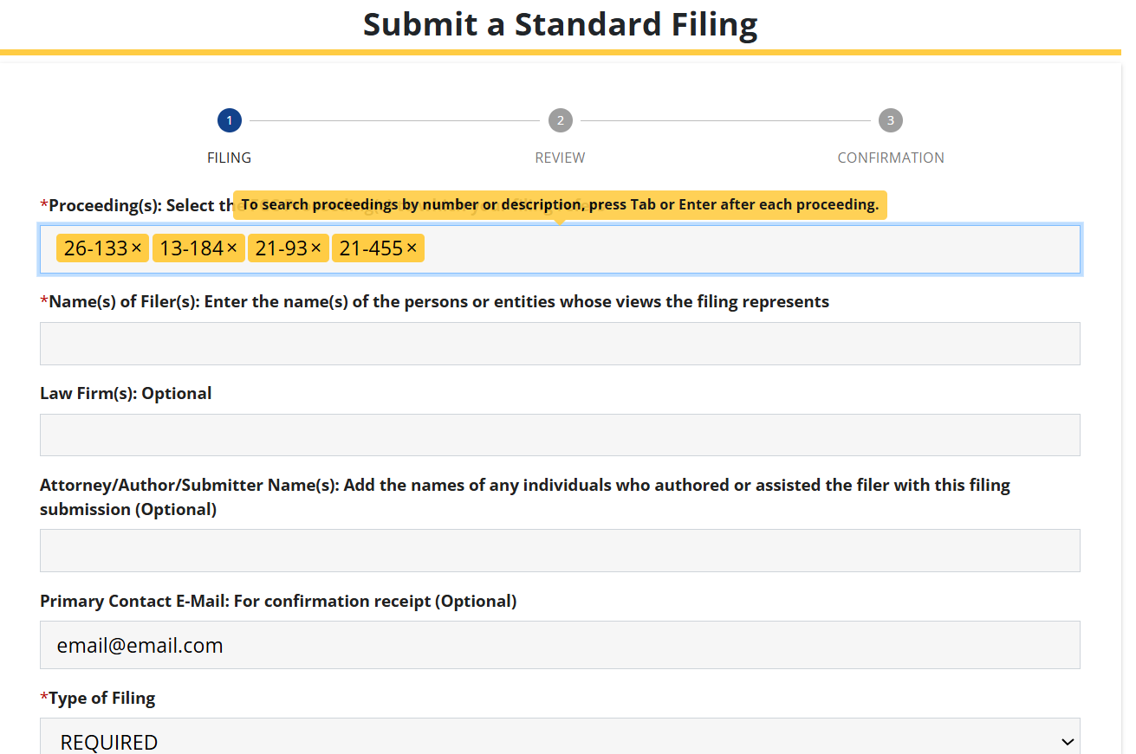

Use the Filing drop-down menu to select “Comments” or "Reply to Comments" (the second item at the top).

Step Four: Continue to Review Screen
After completing the fields in Step Three:
- Choose Email Confirmation "Yes".
- Complete the Acknowledgment.
- Click the "Continue to Review Screen" button.

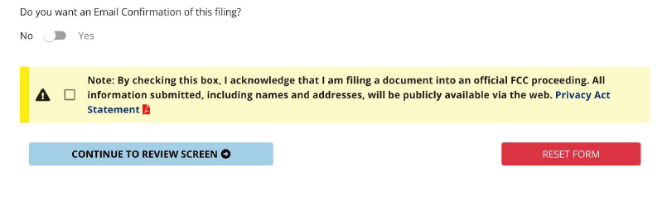

Step Five: Submit the Filing
After completing Step Four:
- Proofread the information on the "Review" Page.
- Click "SUBMIT FILING".

