E-RATE QUICK REFERENCE GUIDE

DISCOUNT MATRIX:
Applicants use the discount matrix to determine the correct discount level for a school district or library system. To receive discounts on eligible services, an applicant must calculate the percentage discount that it (and the entities it represents) is eligible to receive.
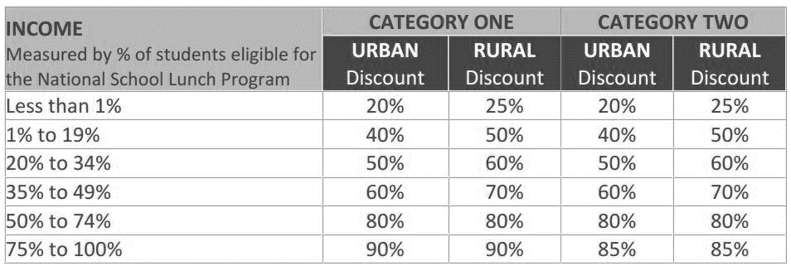

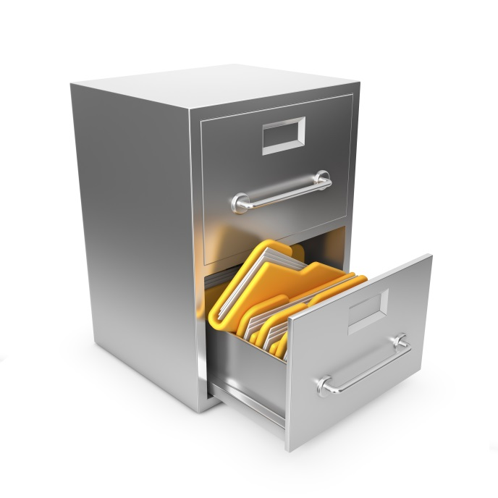
FUNDING YEARS:
E-Rate Year | Period | Program Year
FY 2018 | 07/01/18-06/30/19 | 21
FY 2019 | 07/01/19-06/30/20 | 22
FY 2020 | 07/01/20-06/30/21 | 23
FY 2021 | 07/01/21-06/30/22 | 24
FY 2022 | 07/01/22-06/30/23 | 25

HELPFUL LINKS:
Kellogg & Sovereign® Consulting | www.kelloggllc.com
KSLLC training page | https://www.kelloggllc.com/app_training.aspx
KSLLC live chat | https://www.kelloggllc.com/E-Rate.aspx (scroll to the bottom)
KSLLC applicant forms | https://www.kelloggllc.com/app_forms.aspx
KSLLC bidding site – Bonfire | https://kelloggllc.bonfirehub.com/registration
KSLLC SharePoint – documents | https://kelloggllc.sharepoint.com/sites/clients/XXXX/SitePages/Main.aspx  (copy & paste link and add school code where “XXXX” is)
KSLLC Account Managers | https://www.kelloggllc.com/account_managers.aspx
USAC Erate Productivity Center (EPC) | https://portal.usac.org/suite/
USAC Web Site | https://www.usac.org/e-rate/
FCC E-Rate | http://www.fcc.gov/encyclopedia/e-rate-schools-libraries-usf-program

